USER MANUAL



Smooch Cafe Online Ordering System

Name | Position Title | Role | Signature | Date
Dixon, Kiervin P. | Developer / Documentation-Student | Author
Ilaida, Jannyca D. | Developer-Student | Author
Rivera, James Carl B. | Developer-Student | Author

Objective of your Project:

The objective of this project is to develop a complete and user-friendly website for Smooch Cafe. The website serves as an online platform where customers can explore the cafe’s food, drinks, and pastries. It aims to present the menu in a clear, organized, and visually appealing manner. The project focuses on improving customer experience through simple and smooth navigation. Users can easily browse different menu categories without confusion. The website is designed to be fully responsive for desktop and mobile devices. Interactive elements are added to make the browsing experience engaging. The project also simulates an online ordering process for customer convenience. Users can add items to a shopping cart and review their selections. The cart system helps users track selected items and total cost. A checkout page is included for entering order and contact details. The website supports both pickup and delivery order options. Animations and hover effects enhance visual feedback. The design follows a consistent cafe branding theme. The website helps strengthen Smooch Cafe’s online presence. The project aims to combine functionality, design, and usability in one platform.

Key Features

- Modern and responsive website design

- Online menu for food, drinks, and pastries

- Category-based menu filtering

- Featured and best-selling product display

- Interactive product cards with images and prices

- Add-to-cart functionality

- Cart modal with quantity adjustment

- Checkout page for order details

- Mobile-friendly navigation menu

- Smooth scrolling and hover animations

Step by Step Procedure

- Accessing the Website (Home Page)
  - Home Page Interface
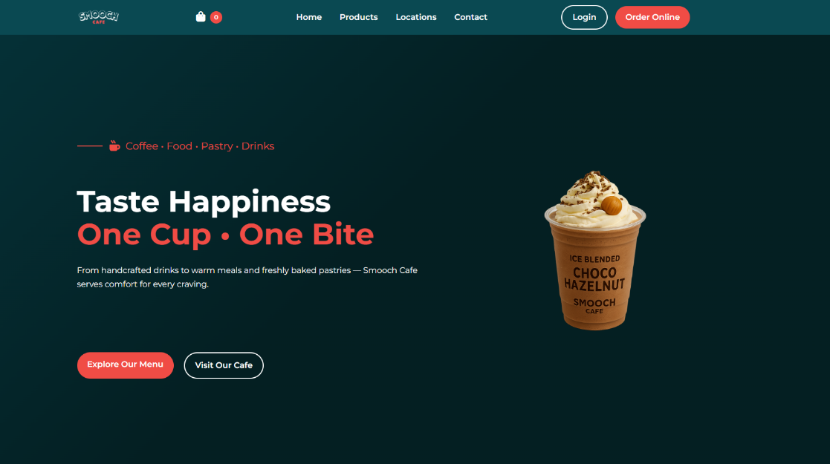
    - Screenshot of the Home page

    - The Home page displays the café branding, hero section, and navigation menu.
  - Navigation Menu
    - User can click Home, Products, Locations, or Contact from the header.
    - The menu is responsive and converts to a hamburger menu on mobile devices

- Browsing the Menu (Products Page)
  - Products Page Display
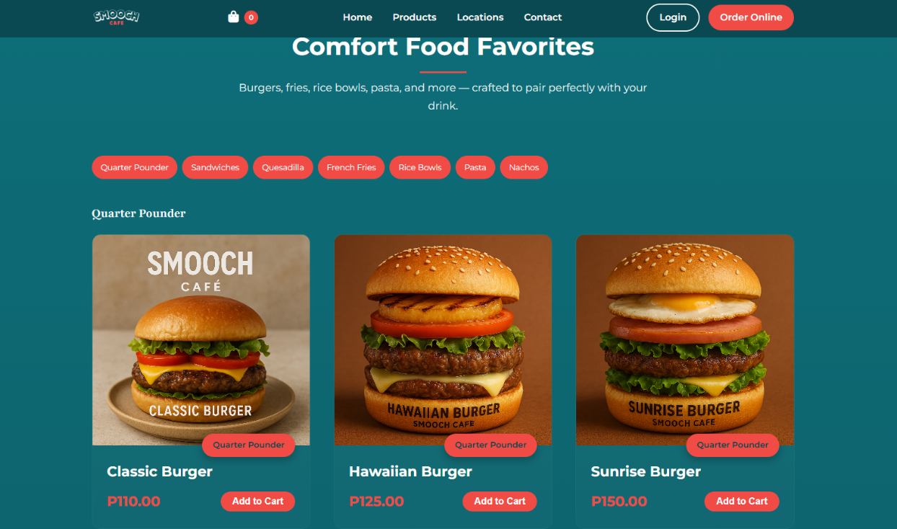
    - Screenshot of the Products page.

    - The page shows food, pastries, and drinks with images and prices.
  - Category Filtering
    - User selects a category using the dropdown filter.
    - The system displays only the selected category items.
  - Product Viewing
    - Products are displayed as cards with name, image, and price.
    - Hover effects provide visual feedback.

- Adding Items to Cart
  - Add to Cart Action
    - User clicks the Add to Cart button on a product.
    - The item is added to the cart.
  - Cart Icon Update
    - Cart item count updates automatically.
    - User can click the cart icon to view selected items

- Viewing the Cart
  - Cart Modal Interface
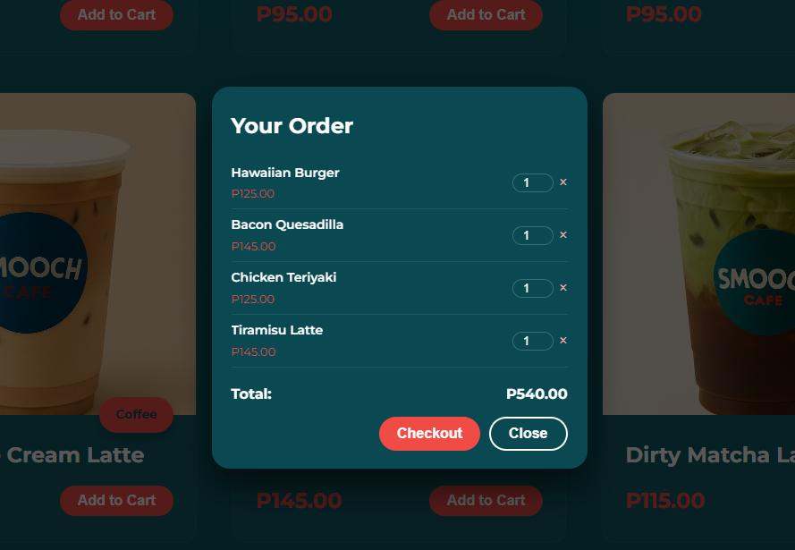
    - Screenshot of the Cart modal

    - The cart displays selected items, quantity, and total price
  - Cart Management
    - User can change item quantity or remove items.
    - Total price updates automatically.

- Checkout Process
  - Checkout Page Access
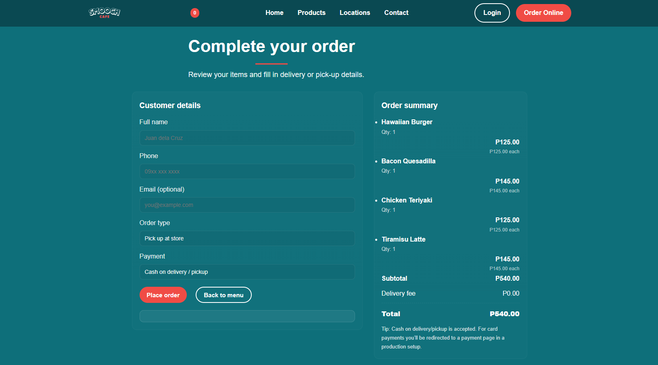
    - Screenshot of the Checkout page

    - User is redirected to the checkout page after clicking Checkout.
  - Customer Details Input
    - User enters name, phone number, and optional email
    - User selects order type (Pick-up or Delivery)
  - Order Submission
    - User submits the order details
    - The system displays an order confirmation message

- Login Modal
  - Login Interface
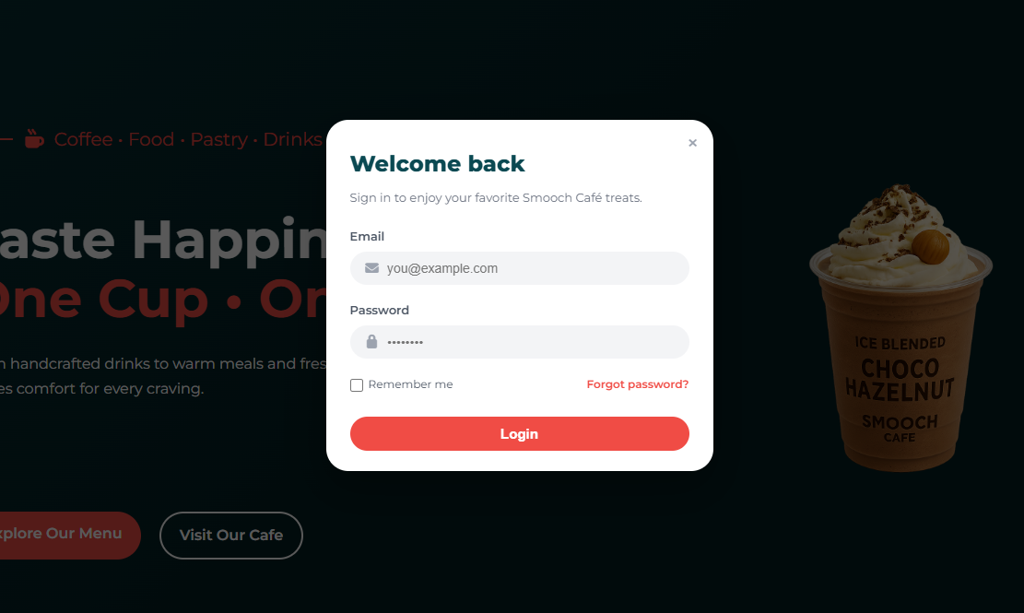
    - Screenshot of the Login modal

    - Login modal can be opened from the navigation menu
  - User Authentication (UI Only)
    - User enters email and password
    - Interface is for design and demonstration purposes.

